Handbook Number: LCSCOT.001.20.DC
Press Reference: 11SCOTCH

Set-up & Operating Instructions For:

The John Hunt Little Champion
Scotch Pie Machine.

John Hunt (Bolton) Ltd
Alma Works, Rasbottom Street, Bolton, England, BL3 5BZ
Telephone: (01204) 532 798 / (01204) 521 831

Website: www.johnhuntbolton.co.uk / www.johnhuntbolton.com
HANDBOOK FOR LITTLE CHAMPION SCOTCH PIE MACHINES
FILE NAME: LCSCOT2020.DOC

CONTENTS

TITLE: PAGE:

INSTALLATION 3
HANDLING
COMMISSIONING

INITIAL SET-UP 4

REGULATING HEAT 5
DIGITAL THERMOSTAT
PROGRAMMING THE THERMOSTAT
SIMMERSTAT

AIR RELEASE 8
WIZ-AIR SYSTEM
AIR COMPRESSION FITTINGS

GENERAL OPERATION 10
ROTARY DIE SET SYSTEM
PRESSING ISSUES

MAINTENANCE 13
CLEANING OF MACHINERY
CLEANING OF DIE EQUIPMENT
OILING & LUBRICATING
HEALTH & SAFETY

TROUBLESHOOTING 15

SPARE PARTS 16

INTRODUCTION

IDEAL FOR PRODUCTS 100MM (4”) IN DIAMETER.

STANDARD SIZES:
3 ¾” X 1 7/16” (95 X 38MM)
2 ¾” X 1 7/16” (69 X 38MM)
OTHER SIZES AVAILABLE BY QUOTATION.

PLEASE NOTE : FINAL SHELL SIZES WILL MEASURE UP TO 7MM (1/4”) IN DIAMETER LESS THAN THE DIE SIZE. WILL PRODUCE UP TO 240 SHELLS PER HOUR.

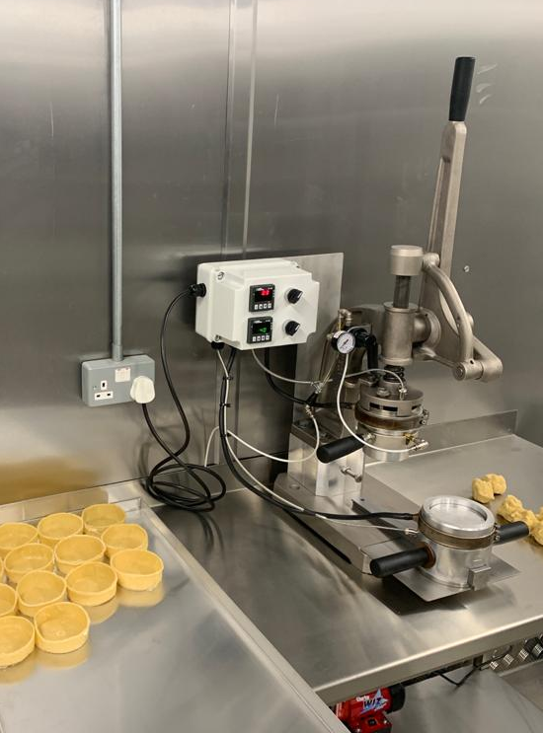
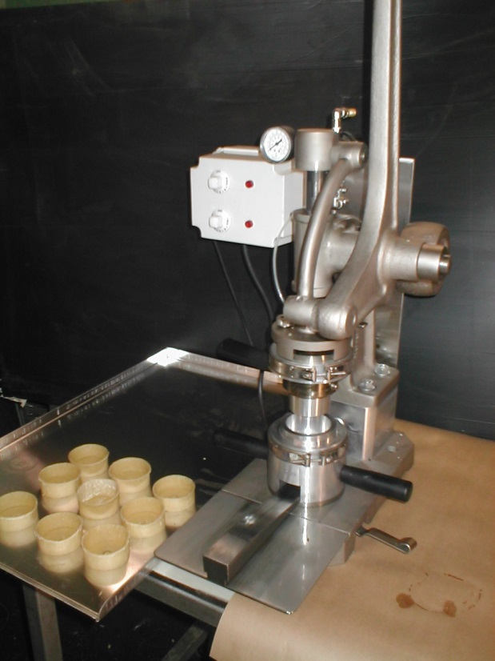

FORMING DIE AND BASE DIE ARE BOTH ELECTRONICALLY HEATED AND ARE INDEPENDENTLY CONTROLLED BY DIGITAL THERMOSTATS.
COMPRESSED AIR RELEASE SYSTEM OFFERS SMOOTH OPERATION AND EASY RELEASE.
ADDITIONAL SCOTCH DIE SETS CAN BE USED OF VARYING SIZES – STATE MACHINE IS SCOTCH WHEN ENQUIRYING.
PAINT FREE SURFACES. ALL CASTINGS ARE ELECTROLESS NICKEL PLATED.

SIMPLE TO OPERATE AND SUPPORTED BY HUNTS LEGENDARY RELIABILITY AND SPARES BACK UP. OVER 100 YEARS OF EXPERIENCE MANUFACTURING ALL TYPES OF PIE MACHINES AND EXPORTING WORLDWIDE.

* JOHN HUNTS POLICY IS ONE OF CONTINUOUS DEVELOPMENT AND THE RIGHT IS RESERVED TO CHANGE SPECIFICATIONS AT ANY TIME WITHOUT PRIOR NOTICE
SUPPLY REQUIREMENTS
ELECTRICAL

VOLTAGE : 220V – 1PH . EARTH & NEUTRAL
AMPS : 13A SUPPLY

COMPRESSED AIR CONNECTION

10MM (3/8”) INTERNAL BORE BRAIDED FLEXIBLE PVC AIRLINE PIPE (IF USING THE WIZ-AIR MINI COMPRESSOR, THIS WILL ATTACH DIRECT TO THE DIE FITTING)

COMPRESSED AIR SUPPLY

COMPRESSED AIR FLOW RATE: 10M3/H OR 6 CFM (MINIMUM)
COMPRESSED AIR PRESSURE: 29 PSI OR 2 BAR (MINIMUM)

DIMENSIONS & WEIGHT

HEIGHT : 1725MM
WIDTH : 900MM
DEPTH : 850MM

WEIGHT : 48KGS

HANDLING

WE RECOMMEND THAT THE MACHINE IS HANDLED WITH A PALLET TRUCK OR TROLLEY UNTIL UNPACKED AT WHICH POINT IT CAN BE MANOUVERED INLINE WITH YOUR OWN MANUAL HANDLING POLICY. WHEREVER POSSIBLE AVOID MANUAL HANDLING. PLEASE ENSURE ENOUGH PEOPLE RELEVANT TO THE MACHINE WEIGHT, AND IN LINE WITH YOUR HEALTH & SAFTEY POLICIES ARE INVOLVED IN MOVING THE MACHINE WHERE NO ALTERNATIVE IS AVAILABLE.

COMMISSIONING

DIE SET COMPONENTS MAY BE GREASED BEFORE DISPATCH TO PREVENT RUSTING. IT IS RECOMMENDED THAT ANY EXCESS IS WIPED CLEAN.
MACHINES ARE GREASED AND OILED PRIOR TO DISPATCH. IN MOST CASES THIS WILL NOT CAUSE ANY ISSUES, HOWEVER UPON OCCASION EXCESS OIL MAY RUN DOWN THE MAIN DOWNSHAFT AND ON TO THE DISC. THIS IS NOT A LEAK AND NO CAUSE FOR CONCERN, SIMPLY WIPE AWAY ANY EXCESS AND AFTER A SHORT TIME THIS WILL STOP.

PLEASE NOTE : BEFORE OPERATING THE MACHINE. THE MACHINE SHOULD BE IN POSITION WITH ALL PACKAGING REMOVED AND SECURED TO THE BENCH WITH 2 SUITABLE NUTS & BOLTS.

PAGE: 3
WITH THE MACHINE SITED AND SECURED, EXCESS GREASE AND OIL WIPED CLEAN; PLEASE PROGRESS TO INITIAL SET-UP GUIDELINES.

INITIAL SET-UP

CHECK THE SUPPLY. THE MACHINE 220V SINGLE PHASE, NEUTRAL AND EARTH.

IN ORDER TO USE YOUR MACHINE YOU WILL NEED TO MOUNT THE DIE SET AS FOLLOWS;

- BASE DIE – THIS IS PLACED ON TO THE BASE OF THE MACHINE BY PLACING THE “PEG” ON THE UNDERSIDE OF TRACK SYSTEM INTO THE SITING HOLE IN THE CENTRE OF THE BEDPLATE. THE BASE DIE CAN THEN SLIDE ONTO THE TRACK ENSURING THE SLOTTED SECTION OF THE BASE IS ALIGNED WITH THE TRACK.
- BLOCKING / LIDDING DIES – THESE DIES ARE ATTACHED TO THE DISC OF THE MACHINE UTILISING THE GLAND STUDS. PLACE THE STUDS THROUGH THE GUIDE HOLES IN THE DISC AND TO SECURE IN POSITION PLACE A KNURLED NUT ONTO THE TOP OF THE GLAND STUD AND TURN CLOCKWISE TO TIGHTEN AND SECURE . REPEAT FOR THE SECOND STUD.

THE HEATING ELEMENTS ARE PRE-CONNECTED. AS STANDARD THESE ARE WIRED INTO A TEMPERATURE CONTROL BOX WHICH IS SUPPLIED WITH A 13 AMP STANDARD UK PLUG AND CAN BE PLUGGED DIRECTLY IN TO A WALL SOCKET. OLDER MACHINES MAY HAVE BEEN SUPPLIED WITH A SIMMERSTAT. THIS IS NO LONGER RECOMMENDED PLEASE CONTACT US TO UPDATE YOUR MACHINE WITH A DIGITAL THERMOSTAT*(CHARGES APPLY). PLEASE SEE REGULATING HEAT SECTION FOR MORE DETAILS.

CAUTION! ONCE THE HEATING ELEMENT(S) IS CONNECTED TO AN ELECTRIC SUPPLY IT WILL BEGIN TO HEAT UP. DO NOT TOUCH THE DIE WITHOUT ADAQUETE PROTECTION.

FOR DETAILS ON CONNECTING YOUR AIR SUPPLY SHOULD YOU HAVE THE OPTION, PLEASE SEE AIR RELEASE SECTION.

PAGE: 4

REGULATING HEAT

HEAT IS REQUIRED IN THE PRODUCTION OF SCOTCH PIE CASES TO HELP IN PREVENTING THE PASTRY STICKING TO THE DIE ON RELEASE AND IN SOME CASES TO ASSIST IN THE PRESSING OUT OF BASES. THE HEAT REQUIRED TO ACHIEVE THIS WILL VARY DEPENDING ON THE FOLLOWING FACTORS:

- FRESHNESS OF DOUGH / PASTRY MIX
- TEMPERATURE OF DOUGH / PASTRY MIX
- AMBIENTE ROOM TEMPERATURE
- STICKINESS / TACKINESS OF THE DOUGH
- PATRICLE CONTENT OF THE MIX
- BASE INGREDIENTS
- HOW WET THE MIX IS
- QUANTITY OF DOUGH / PASTRY TO BE PRESSED
- SIZE OF PRODUCT TO BE PRESSED
- IS IT PRE-ROLLED
- DESIRED TEXTURE OF FINISHED SHELL / PERSONAL PREFERENCE

ALL THE ABOVE WILL HAVE AN EFFECT ON HOW MUCH HEAT IS REQUIRED.

DIGITAL THERMOSTAT

IF YOU HAVE PURCHASED A DIGITAL THERMOSTAT IT WILL HAVE A SINGLE PHASE PLUG FOR THE POWER SUPPLY. ON THE OTHER END IS THE BAYONET PROBE, THIS WILL NEED TO BE IN SITU ON THE DISC LOCKING IT INTO POSITION ON THE THERMOCOUPLE. THE BAYONET PROBE REGISTERS THE TEMPERATURE OF THE DIE AND RELAYS IT BACK TO THE THERMOSTAT (RED DIGITS ON CONTROLLER REPRESENT CURRENT TEMPERATURE OF THE DIE) WHICH WILL CUT POWER WHEN REQUIRED IN ORDER TO REGULATE THE TEMPERATURE WITHIN A SMALL TEMPERATURE RANGE (GREEN DIGITS ON CONTROLLER REPRESENT THE TEMPERATURE THE THERMOSTAT IS ATTEMPTING TO REACH).

ONCE THE THERMOSTAT IS SET-UP YOU SHOULD SELECT A TEMPERATURE. IF AFTER A SHORT PERIOD OF TIME EITHER THE DOUGH MIX IS STILL STICKING OR IT IS EXCESSIVELY DIFFICULT TO PRESS OUT THE BASE PASTRY, THE TEMPERATURE IS TO BE INCREASED GENTLY IN SMALL INCREMENTS UNTIL THE ISSUE IS RESOLVED. IF YOUR PASTRY MIX BEGINS TO “SHRINK BACK” THEN THE TEMPERATURE IS TOO HIGH AND THE HEAT SHOULD BE REDUCED. YOU ARE AIMING FOR A TEMPERATURE WHEREBY THE MIX DOES NOT STICK AND ALSO DOES NOT SHRINK BACK.

PROGRAMMING THE THERMOSTAT

THE FOLLOWING PROCESS IS TO BE FOLLOWED WHEN SETTING THE THERMOSTAT:

- PRESS “P”
- “SP1” WILL BEGIN TO FLASH
- USING THE UP AND DOWN ARROWS – SELECT THJE DESIRED TEMPERATURE (GREEN)
- PRESS “P” TO CONFIRM SETTINGS AND LEAVE 5 SECONDS OR PRESS “U” TO EXIT

**OTHER SETTINGS SUCH AS ALARM, TEMPERATURE AND TIMER VALUES CAN ALSO BE SET IN THE SAME WAY, IF SELECTED.
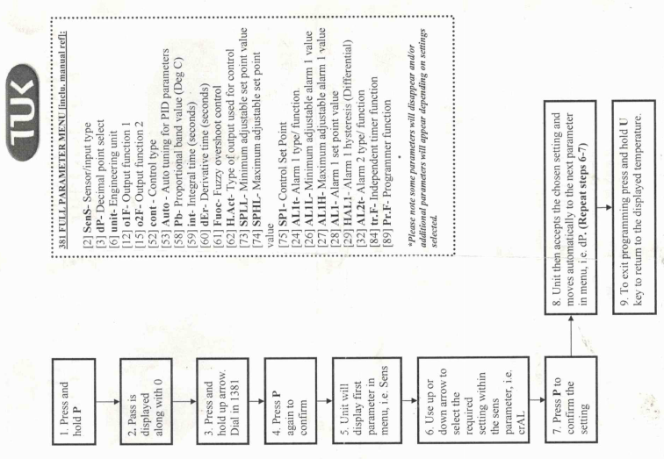

ON-SITE TESTING WITHIN OUR FACILITY SHOWED SUCCESS WITHIN THE FOLLOWING RANGES, THESE ARE ONLY TO BE SEEN AS A GUIDE AND THE AFOREMENTIONED FACTORS SHOULD BE TAKEN INTO CONSIDERATION.

TOP DIE (REPRESENTED BY THE TOP DIGITAL CONTROLLER) : 88 - 95 DEGREES
BOTTOM OR BASE DIE (REPRESENTED BY BOTTOM DIGITAL CONTROLLER) : 140 – 145 DEGREES

PLEASE NOTE:

YOU CAN ACHIEVE DIFFERENT RESULTS BY HOLDING THE MAIN BLOCKING DIE IN ITS DOWNWARD MOST POSITION FOR VARYING LENGTHS OF TIME, USUALLY NOT EXCEEDING 5 SECONDS. FOR EXAMPLE : 5 SECONDS HELD DOWN AT 88 DEGREES TOP BLOCK TEMPERATURE WILL ACHIEVE A DIFFERENT RESULT TO 2 SECONDS HELD DOWN AT 95 DEGREES TOP BLOCK TEMPERATURE.
THIS IS SOMETHING THAT WILL REQUIRE A TESTING PHASE TO ACHIEVE YOUR PERSONAL PREFERENCE IN REGARDS TO YOUR PRODUCT.

SIMMERSTAT

IF YOU HAVE PURCHASED A SIMMERSTAT IT WILL HAVE A SINGLE PHASE PLUG FOR THE POWER SUPPLY, ON THE OTHER END IS A 3 PIN CONNECTOR BLOCK WHICH FITS DIRECTLY IN TO THE END OF THE ELEMENT.
A SIMMERSTAT IS A HEAT CONTROL MECHANISM, IT IS NOT A THERMOSTAT. THAT IS TO SAY IT DOES NOT MAINTAIN THE DIE AT A SPECIFIC TEMPERATURE RANGE. THE NUMBERS ON THE OPERATING DIAL 1-5 GIVE AN IDICATION OF THE LENGTH OF TIME CURRENT IS SUPPLIED TO THE ELECTRIC ELEMENT, 1 BEING THE SHORTEST PULSE & 5 BEING CONSTANT .
PLEASE NOTE: SELECTING OPTION 5 WILL LEAVE A CONSTANT FLOW OF POWER TO THE ELEMENT.

THE SIMMERSTAT WILL ALLOW CURRENT TO THE ELEMENT AT INCREASING INTERVAL LENGTHS CORRESPONDING TO HOW HIGH A NUMBER IS SELECTED.
ON FIRST USE, IT IS RECOMMENDED YOU SELECT NUMBER 3 WITH THE DIAL. IF AFTER A SHORT PERIOD OF TIME EITHER THE DOUGH MIX IS STILL STICKING OR IT IS EXCESSIVELY DIFFICULT TO PRESS OUT THE BASE PASTRY, THE TEMPERATURE IS TO BE INCREASED GENTLY IN SMALL INCREMENTS (YOU CAN SELECT BETWEEN NUMBERS) UNTIL THE ISSUE IS RESOLVED.
THE LIGHT ON THE SIMMERSTAT WILL INDICATE WHEN TURNED ON AND OFF.
CAUTION: SHOULD YOU STOP PRODUCTION FOR ANY LENGTH OF TIME IT IS ESSENTIAL TO SWITCH THE SIMMERSTAT TO THE OFF POSITION. IF THIS IS NOT DONE THE DIE MAY WELL OVERHEAT CAUSING POSSIBLE DAMAGE.

CAUTION! DIE SETS CAN BECOME VERY HOT AND SHOULD NOT BE HANDLED WITHOUT APPROPRIATE PROTECTIVE HAND WEAR. PLEASE ALLOW THE DIES SUFFICIENT TIME TO COOL BEFORE HANDLING.

PAGE: 7
AIR RELEASE

AIR RELEASE IS A SYSTEM THAT HELPS BOTH, LIFTING OF PRODUCTS AND WHERE APPLICABLE BASE EJECTION.

WHEN PASTRY IS PLACED IN TO A CONTAINER IT IS FULL OF SMALL POCKETS OF AIR, THESE ARE FORCED OUT OF THE CONTAINER DURING THE BLOCKING OUT OF A BASE. DUE TO THE AIR BEING REMOVED THIS EFFECTIVELY CAUSES A VACUUM WITHIN THE CONTAINER “SUCKING” IT TO THE DIE. IT WAS WIDELY BELIEVED THAT DEEP, STRAIGHT SIDED CONTAINERS WERE THE WORST AFFECTED, WHILST THIS IS TRUE MOST CONTAINERS WILL SEE AN IMPROVEMENT WITH THE USE OF AIR RELEASE. FOILS CAN BECOME DISTORTED SHOULD A VACUUM BE GENERATED AND TINS CAN SUFFER FROM LIFTING AND REQUIRE ADDITIONAL HELP TO BE FREED. KNOCK OFF PINS ARE PRESENT ON MOST DIES AND WILL AID IN PUSHING THE CONTAINER FREE AS WELL. THE AIR IS PASSED THROUGH A BRASS AIR VALVE IN THE CENTRE OF THE DIE.

WIZ-AIR SYSTEM

THE WIZ AIR SYSTEM IS A SILENT RUNNING TABLE TOP COMPRESSOR THAT PLUGS IN TO THE ELECTRIC SUPPLY VIA A SINGLE PHASE SOCKET. THE WIZ AIR CONNECTS TO THE BLOCKING DIE VIA THE ELBOW AIR FITTING BEING PUSHED ON TO THE BRASS AIR INLET PIPE OF THE DIE, A SMALL COLLAR AROUND THE END OF THE ELBOW CAN BE DRAWN BACK AND WILL ALLOW THE ELBOW TO BE REMOVED FROM THE INLET PIPE IF REQUIRED. ONCE CONNECTED AS ABOVE THE WIZ-AIR SHOULD BE TURNED ON VIA THE SWITCH ON THE UNIT. THIS WILL THEN BE FULLY FUNCTIONAL, THE UNIT CANNOT GENERATE MORE THAN 2.5BAR – 3BAR WHICH MEANS IT WILL NEVER GENERATE TOO MUCH AIR SUPPLY TO CAUSE PROBLEMS AND THEREFORE DOESN’T NEED REGULATING. ANY FORM OF AIR SUPPLY WILL BE SUFFICIENT, YOU ARE ONLY LOOKING TO REPLACE THE AIR FORCED OUT DURING THE PRESSING PROCESS.

THE WIZ-AIR IS NOT COMPATIBLE WITH BASE AIR EJECTION.

AIR COMPRESSION FITTINGS

IF YOU HAVE BEEN SUPPLIED THE MACHINE WITH AIR FITTINGS ATTACHED, YOU WILL NEED TO CONNECT YOUR OWN COMPRESSOR TO THE FITTINGS ON THE SIDE OF THE MACHINE AND AS WITH THE WIZ-AIR CONNECT THE AIR ELBOW TO THE DIE AIR INLET PIPE (SEE ABOVE FOR MORE INFORMATION). AIR FLOW FROM YOUR COMPRESSOR WILL NEED REGULATING TO ANYTHING BETWEEN 1.5BAR – 3BAR USING THE REGULATOR AND DIAL ON THE SIDE OF THE MACHINE.

PAGE: 8

PAGE: 9

GENERAL OPERATION

THE GENERAL OPERATION OF THE MACHINE IS AS FOLLOWS ENSURING DIES ARE APPROPRIATELY HEATED AND AIR RELEASE SYSTEMS TURNED ON (WHERE APPLICABLE):

ROTARY DIE SET SYSTEM (FOR OPEN PRODUCTS)

THE BLOCKING DIE SHOULD BE MOUNTED ON THE MACHINE AS DETAILED ABOVE AND THE BASE DIE LOCATED ON THE BED PLATE TRACK SYSTEM.
PLACE YOUR FIRST AMOUNT OF PASTRY / DOUGH MIX INSIDE THE BASE(THIS DOES NOT NEED TO WEIGHED) WHICH WILL HAVE BEEN CAREFULLY DRAWN BACK ALONG THE TRACK TO A POSITION WHEREBY IT IS NOT IMPEDED BY THE BLOCKING DIE. CAUTION: THERE IS NO “STOP” ON THIS END OF THE TRACK TO ALLOW FOR EASIER CLEANING – TAKE CARE NOT TO DRAW THE BASE BACK TOO FAR AND OFF THE TRACK. ONCE THE DOUGH IS PLACED, THE BASE DIE USING TWO HANDS SHOULD BE PUSHED ALONG THE TRACK UNTIL IT HITS THE “DEAD STOP” AT THE END OF THE TRACK AND IS DIRECTLY BELOW THE BLOCKING HEAD. USING THE LEFT HAND THE OPERATOR SHOULD PUSH BACK THE ROTARY HANDLE ON THE BLOCKING DIE (OPERATES THE CUT-OFF) THIS WILL ALLOW A CLEAN MOVEMENT THROUGH TO THE BOTTOM OF THE STROKE, USING THE RIGHT HAND (STILL PUSHING THE ROTARY HANDLE BACK WITH THE LEFT HAND) PULL THE LEVER ARM HANDLE UNTIL THE MACHINE “BOTTOMS” THIS IS INDICATED BY THE HEAD OF THE DOWNSHAFT TOUCHING THE STAND, WHILST HOLDING THE LEVER ARM IN POSITION WITH YOUR RIGHT HAND FOR A NUMBER OF SECONDS NOT EXCEEDING 5 SECONDS (THIS WILL EVENTUALLY BE BASED ON YOUR TESTING PERIOD) YOUR LEFT HAND SHOULD BE USED TO OPERATE THE CUTTING RING ON THE BLOCKING DIE VIA THE BLACK HANDLE ON THE SIDE OF IT. THIS WILL TRIM OFF EXCESS PASTRY. YOU SHOULD CONTINUE DRAWING THE ROTARY DIE HANDLE TOWARD YOU AS YOU RETURN THE LEVER ARM BACK TO ITS STARTING POSITION, PUSH THE ROTARY DIE HANDLE AWAY FROM YOURSELF TO RELEASE ANY EXCESS PASTRY STUCK TO THE CUTTING RING. IF THE RESULT IS NOT SATISFACTORY YOU MAY NEED TO ADD MORE PASTRY MIX TO ENSURE COMPLETE COVERAGE OF THE CONTAINER.
ABOVE IS THE RECOMMENDED METHOD OF OPERATION, HOWEVER IT DOES COME DOWN TO PERSONAL PREFERENCE AND RESULTS.

PLACE YOUR INGREDIENTS IN TO THE PASTRY SHELL AND LID TO COMPLETE YOUR PRODUCT.

PAGE: 10
CAUTION! DIE SETS CAN BECOME VERY HOT AND SHOULD NOT BE HANDLED WITHOUT APPROPRIATE PROTECTIVE HAND WEAR. PLEASE ALLOW THE DIES SUFFICIENT TIME TO COOL BEFORE HANDLING.

PRESSING ISSUES

ISSUES CAN ARISE DURING PRESSING AND IT CAN APPEAR DIFFICULT OR EXCESSIVE TO PRESS YOUR PRODUCT. WITH THE MASSIVE VARIETY OF SHAPES, SIZES, AND DOUGH MIXES. THERE ARE A NUMBER OF THINGS TO CONSIDER THAT MAY HELP IMPROVE THE PROCESS.

INITIALLY, THE PASTRY. MOST TYPES OF PASTRY WORK WITH OUR MACHINES AND DIE SETS, HOWEVER YOU MAY NEED TO ALTER HOW YOU CURRENTLY WORK TO GET THE BEST RESULTS.

- THE IDEAL TEMPERATURE OF THE DIE HAS BEEN ADOPTED AND AIR RELEASE IS AVAILABLE AND TURNED ON.
- PASTRY IS AS FRESH AS IS REASONABLY PRACTICABLE.
- PASTRY IS AS NEAR TO ROOM TEMPERATURE AS POSSIBLE, IF THE PASTRY IS TOO COLD YOU WILL FIND IT DIFFICULT TO PRESS. ALLOWING THE PASTRY TO REST AT ROOM TEMPERATURE FOR AROUND AN HOUR BEFORE HAND WILL IMPROVE THE PRESSING PROCESS.
- FOR LARGER, DEEPER PRODUCTS YOU MAY BE BEST SERVED TO PRE-ROLL YOUR PASTRY OR AT THE LEAST ENCOURAGE IT OUT IN TO A THINNER MORE DISC LIKE SHAPE. A DISC OR
- HOT WATER PASTRY NEEDS TO BE DIVIDED AND HAVE TIME TO RELAX TO GET THE BEST RESULTS.
- PRE-ROLLED PASTRY IS EASY TO FORM IN TO SHAPE THAN A BALL OF PASTRY.
- THE MACHINE IS WELL LUBRICATED (SEE MAINTENANCE)
- THE MACHINE IS FUCTIONING CORRECTLY.

NOTES

USE THIS AREA TO MAKE ANY NOTES ABOUT YOUR PRODUCT/MACHINE SPECIFICS, ETC…

PAGE: 12
MAINTENANCE

CLEANING OF MACHINERY

IT IS ESSENTIAL FOR HEALTH & SAFETY PURPOSES AND GENERAL MAINTENANCE OF THE MACHINERY THAT CLOSE ATTENTION BE PAID TO REGULAR AND SYSTEMATIC CLEANING.

PLEASE NOTE: ANY POWER SUPPLY SHOULD BE DISCONNECTED

AT THE END OF EACH DAY (OR SHIFT) THE MACHINE SHOULD BE CLEANED. LOW PRESSURE COMPRESSED AIR TOOLS CAN BE VERY USEFUL FOR REMOVING PASTRY, ETC FROM DIFFICULT TO REACH PLACES. WEAR PROTECTIVE GLASSES AND MAKE SURE THAT THE AREA IS CLEAR OF OTHER PERSONNEL.
WIPE THE MACHINE DOWN WITH PROPRIETARY CLEANING PRODUCTS. DO NOT POWER WASH OR IMMERSE THE MACHINERY IN WATER. THOROUGHLY DRY THE MACHINES.
SOME OF OUR MACHINES INCORPORATE HEATING ELEMENTS. EVEN THOUGH THE MACHINE IS NO LONGER IN OPERATIONTHE DIE EQUPMENT MAY STILL BE HOT. BE AWARE OF THIS FACT BEFORE CARRYING OUT ANY CLEANING.

GREASING AND OILING THE MACHINE ON A MONTHLY TO QUARTERLY BASIS WITH FOODSAFE LUBRICANTS IS RECOMMENDED AND WILL SEVERLY IMPROVE THE ONGOING PERFORMANCE OF YOUR MACHINE.

ONLY USE FOOD SAFE LUBRICANTS SUCH AS FOODLUBE, ETC

PLEASE NOTE: NEVER LUBRICATE YOUR MACHINE WITH VEGETABLE OIL, THIS WILL CAUSE THE MACHINE TO CEASE UP AND BECOME UNUSABLE.

CLEANING OF DIE EQUIPMENT

CLEAN THE DIE AFTER EACH USE. CAUTION: THE DIE EQUIPMENT MAY BE HEAVIER THAN YOU IMAGINE! IT MAY ALSO BE HOT – SO WEAR PROTECTIVE GLOVES. REMOVE ANY BAKED ON PASTRY WITH A STIFF BRUSH. WIPE CLEAN. ALWAYS DRY THOROUGHLY AFTER CLEANING. DO NOT IMMERSE IN WATER. LUBRICATE WITH FOOD QUALITY GREASES WHERE APPROPRIATE. CHECK THE SPRINGS ARE FUNCTIONING CORRECTLY.

OILING & LUBRICATING

IT IS IMPORTANT TO OIL THE MACHINE ON A REGULAR BASIS COMPARIBLE TO THE AMOUNT OF USE. MONTHLY TO QUARTERLY SHOULD BE SUFFICIENT. OIL / GREASE THE DOWNSHAFT ABOVE THE STAND AND EACH OF THE FOUR OIL PORTS (1 EITHER SIDE OF THE LEVER ARM AND 1 ON THE TOP AND BOTTOM OF THE LINK). PLEASE NOTE : DO NOT FILL THESE HOLES OR OTHERWISE BLOCK THEM, CLEAN THEM REGULARLY REMOVING ANY BUILT UP PASTRY DEPOSITS.

ONLY USE APPROVED FOOD GRADE OILS & LUBRICANTS, THESE ARE AVAILABLE FROM JOHN HUNT (BOLTON) LTD WHERE REQUIRED.
PAGE: 13
THE DIE MAY REQUIRE LUBRICATION TO MOVING PARTS ASWELL.

HEALTH & SAFETY

- ENSURE THE MACHINE IS SECURED TO A WORK BENCH BEFORE USE.
- AVOID MANUAL HANDLING WHEN MOVING THE MACHINE.
- TAKE GREAT CARE WHEN HANDLING DIE EQUIPMENT, IT MAY BE HOT! AND THEY ARE HEAVY. USE APPROPRIATE PROTECTIVE EQUIPMENT.
- MACHINES AND DIES SHOULD BE CLEANED AND DRIED AFTER EACH PRODUCTION CYCLE.
- ENSURE OPERATORS HANDS ARE FREE OF THE PRESSING AREA, DURING OPERATION.
- ONLY 1 PERSON SHOULD OPERATE THE MACHINE AT ANY GIVEN TIME.
- IF A COMPONENT FAILS, ELECTRICAL OR MECHANICAL: CEASE OPERATION, TURN OFF ANY POWER SUPPLY AND CONTACT JOHN HUNT ON 01204 532 798.
- ALWAYS WEAR PROTECTIVE GLASSES WHEN REMOVING DEBRIS FROM MACHINE AND DIES WITH COMPRESSED AIR TOOLS.

PAGE: 14
TROUBLESHOOTING

FAULT DIAGNOSIS AND REMEDIAL ACTION

Issue | Action to be taken | Still Faulting
Machine Operation Difficult | Apply oil to the 4 oiling wells and grease main spindle. Clean with WD40 first. PLEASE NOTE: Do not use vegetable oil. Use a food safe lubricant i.e. Foodlube | Link Arm/Link Pins could be worn or distorted & in need of replacement.
Die Equipment Difficult to Use | Dissemble die equipment. Clean all surfaces with stiff brush. Apply grease to metal to metal surfaces. Do NOT immerse die equipment in water. Always clean & dry after use. | Send to JH for diagnostic.
Die Equipment Not Heating | Element Fault/Element Power Cable  Thermocouple Not Operating Correctly.
Die Equipment Not Releasing Containers efficiently | AIR RELEASE: Check air valve and clean where appropriate. Increase air pressure where possible. Check pipe systems for leaks. | Send to JH for diagnostic.
 | NON AIR RELEASE: Remove, clean & grease Knock off pins.
Lever Casting does not return to upright position. | Check return spring. Lubricate main downshaft.
Not Pressing to Full Depth. | Hold back rotary handle through full travel of lever. | Damaged Link Pins/Link.

IF YOUR ISSUE IS NOT OUTLINED ABOVE, OR IF THE REMEDIAL SOLUTION HAS NOT BEEN SUCCESFUL PLEASE CONTACT JOHN HUNT ON 01204 532 798

WHENEVER MAKING CONTACT PLEASE STATE YOUR MACHINE IS A “SCOTCH” LITTLE CHAMPION. THE TROUBLESHOOTING AND SPARES ARE RELEVANT TO THE STANDARD MACHINE HOWEVER MANY ARE STILL RELEVANT.
ELEMENTS FOR THE SCOTCH PIE MACHINES ARE BAND HEATERS.

PAGE: 15
SPARE PARTS
Product Code | Part No. | Description
PIEL23 | 1 | BEDPLATE
PIEL26 | 2 | STAND
PIEL28 | 3 | LEVER
PIEL12 | 4 | DOWNSHAFT WITH HEAD
PIEL06 | 5 | DISC (CASTING ONLY)
PIEL15 | 6 | LINK - STANDARD (5/8" BORE)
PIEL32 | 7 | LEVER SIDE SHAFT
PIEL04 | 8 | TOP LINK PIN
PIEL25 | 9 | BOTTOM LINK PIN
 | 10 | BEDPLATE BRACKET
 | 11 | BEDPLATE B'KT SCREWS 6MM X 12MM CAP HEAD (PKT 2)
PIEL05B | 12 | DISC CATCH ONLY
PIEL05A | 13 | DISC CATCH STUD ONLY
PIEL05 | 14 | DISC CATCH STUD (SPRING WASHER ONLY)
PIEL17 | 15 | BACK BRACKET (FOR DISC)
PIEL03 | 16 | TUBE SPRING
PIEL30 | 17 | BLACK HANDLE ONLY
PIEL29A | 18 | BOLT ONLY FOR HANDLE
PIEL01 | 19 | DISC SPRING
PIEL01A | 20 | DISC SPRING BRACKET - STAINLESS STEEL
 | 21 | STAND BEDPLATE BOLTS 12MM X 50MM (PKT 4)
 | 22 | STAND BEDPLATE BOLT SHAKE PROOF WASHER 20MM (PKT 4)
 | 23 | 15MM WASHERS FOR ABOVE (FOR BEDPLATE) PKT 4))
 | 24 | SIDE SHAFT COLLAR SCREW 10MM X 25MM
PIEL36 | 25 | DISC SECURING SCREW
PIEL33 | 26 | BEDPLATE CATCH
PIEL31 | 27 | STOP COLLAR & SCREW
 | 28 | 12MM NUT (FOR STAND/BEDPLATE BOLT) PKT 4))
 | 29 | 8MM NUT (BEDPLATE BRACKET)
 | 30 | 8MM WASHER (BEDPLATE BRACKET)
 | 31 | 8MM X 16MM GRUB SCREWS (FOR PARTS 7,8,9)
 |  | Additional Parts
PIEL11 | 5 & 15 | L.C DISC COMPLETE WITH BRACKET
PIEL07 |  | LC BACK CATCH
PIEL10 |  | LC FRONT CATCH
PIEL35 |  | DISC SPRING SCREW & BOLT
PIEL15A |  | NON-STANDARD HEAVY DUTY LINK - 3/4" BORE
PIEL29 | 17 & 18 | BLACK HANDLE & BOLT COMPLETE
PIEL34 | 25A | BACK BRACKET SCREW & WASHER 8MM X 20MM (PKT 2)
PIEL31 | 27 & 24 | STOP COLLAR & SCREW FOR SHAFT
PIEL39 | 39 | M12 ZINC PLATED DOMED NUT
PIEL41 |  | AIR RELEASE BRACKET

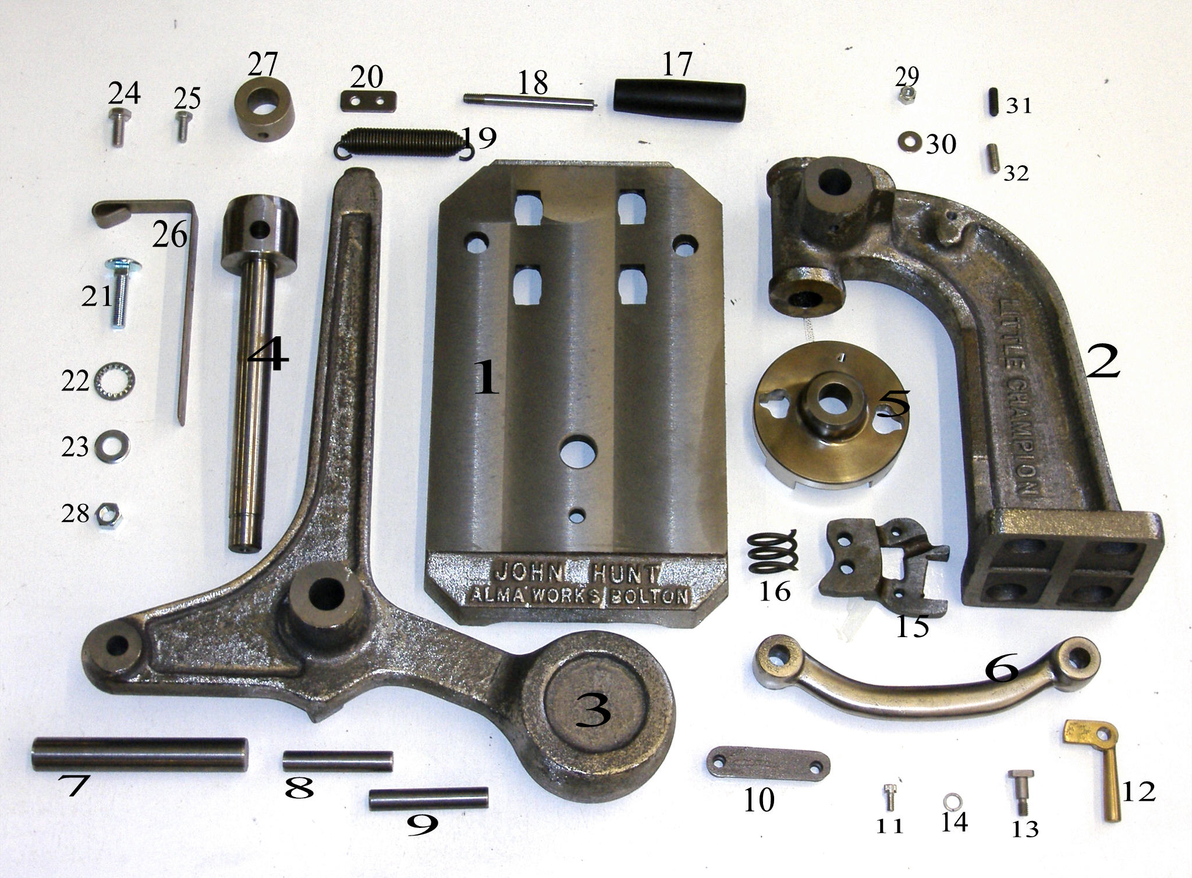

PAGE: 17

